Pick-up
Purpose:
This is a good conditioning drill that is primarily used for pitchers, but can be used early in the season to help condition all players.
Equipment:
2 - 4 baseballs
Setup:
This drill can be done with 2 players or a player and coach. You need a minimum of 2 balls, but I usually grab a couple extra. Player should stand between 10 and 15 feet away from the coach depending on age.
Player will have no glove. Coach will have 2 balls ready and any extras within reach.
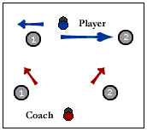
Execution:
Player will get into a fielding position. Coach will start the drill by rolling 1 ball at an angle to the player (Number 1). The player will shuffle to the ball and field it with his bare hands. He will immediately stop and start shuffling in the other direction as he rolls the ball back to the coach. Coach will roll the next ball at an angle to the other side (Number 2). Continue going back and forth for about a minute.
Players should be warmed up before doing this drill. It is tiring and should be used as a conditioning drill towards the end of practice and not as a warmup drill.

